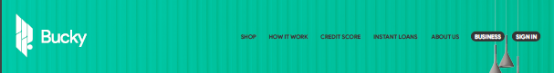

**The Header won’t be looking like this. For inspiration,** please look at[**Affirm**](https://www.affirm.com/)**.**

**The logo will be placed as we have mentioned in our previous meeting**

**The Nav bar for Shoppers and for Business, there will be some changes in color.**

**For the bars**, there will be **Shop, How it works, Credit Score, Financial Wellness.**

**Talk to us** will be included as the previous one

For the cards, It will like [**Affirm**](https://www.affirm.com/)’s Shop Category Section.

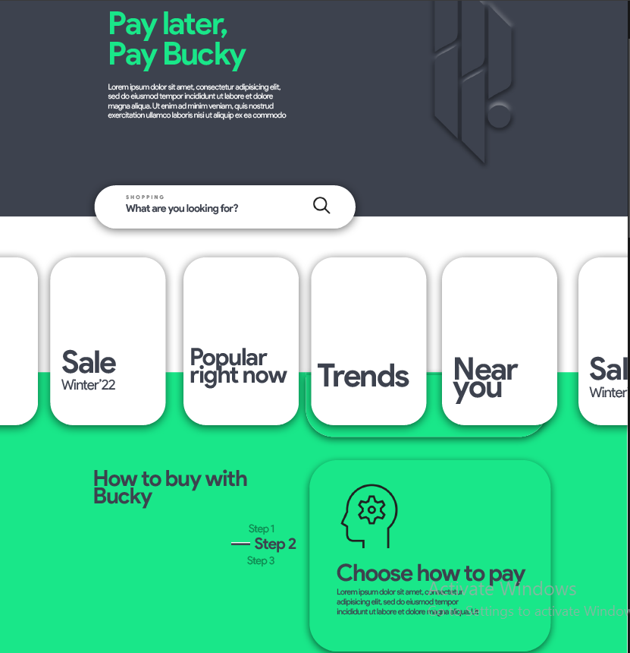

**Pay Later**

**Pay Buckyy**

Make your finances simple with Buckyy! Buy what you want, whenever you want, and pay later.   
Spend your money wisely. We have the best deals and the most transparent installment plans ever. Here’s your chance to pay smart.

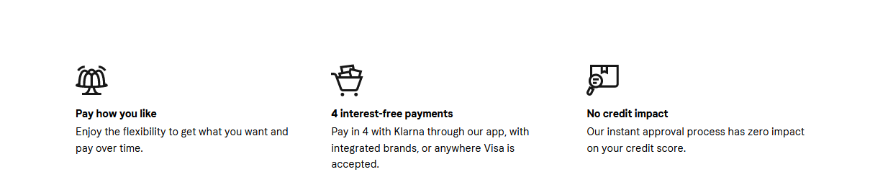Next, Why Buckyy? (The Section will be like this)

1. **Pay in 30 days:**

Enjoy what you’ve ordered right away. Pay for the products through Buckyy after trying them in real life.

1. **Pay in 4:**

Split your payments into 4 equal installments, You just pay for the first installment and pay the rest every 2 weeks.

1. **No Interest, No Catch:**

Interests? Don’t even worry about it. We got you. Pay off the credit with zero interest.

**Follow the following format. Use relevant icons and check if it looks better in the center or left-aligned.**

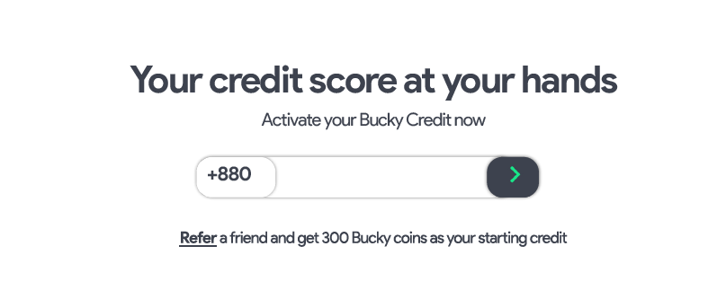

**Refer a friend and get Buckyy reward points**  
The rest of the contents of this section from our given **psd**, will be transferred to credit score page.

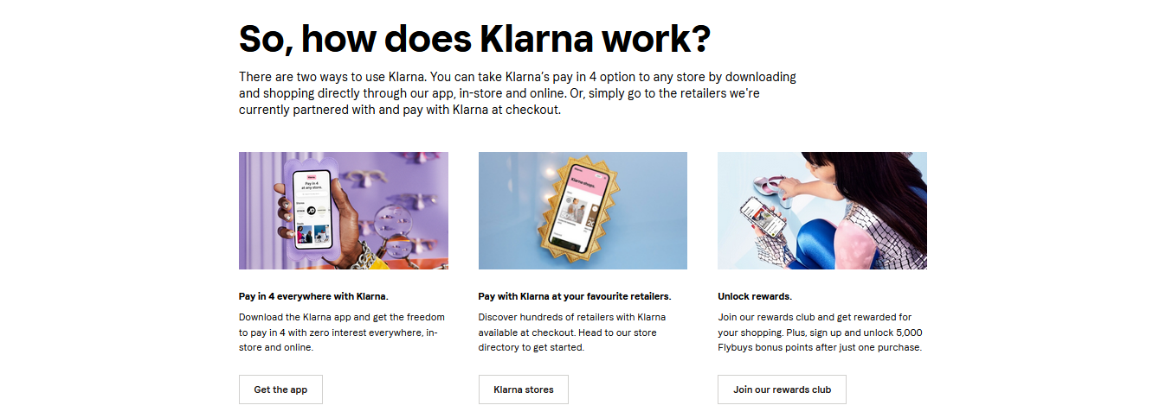  
  
  
**So, how does Buckyy work?**

#### **There are two ways to use Buckyy. You can take Buckyy’s pay in 4 option to any store by shopping directly through our app and online platform, in-store and online. Or, simply go to the retailers we're currently partnered with and pay with Buckyy at checkout scanning the QR Code.**

### **Pay in 4 everywhere with Buckyy.**

Download the Buckyy app or sign up and get the freedom to pay in 4 with zero interest everywhere, in-store and online.

### **Pay with Buckyy at your favorite retailers.**

Discover hundreds of retailers with Klarna available at checkout. Head to our store directory to get started.

### **Unlock rewards.**

Join our rewards club and get rewarded for your shopping.

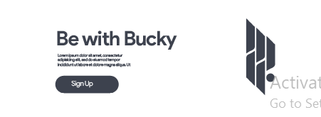

**Be With Buckyy**  
Let us help you simplify your finances.

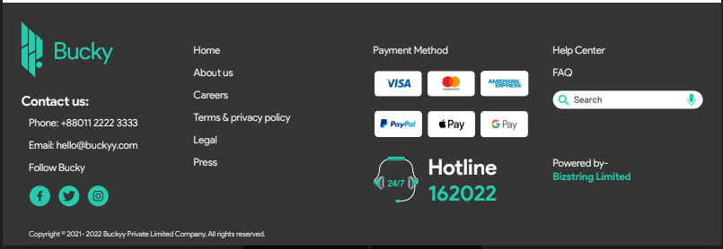

Please put the button of the pages that we have mentioned in the header and change the Hotline look and Delete the search bar.